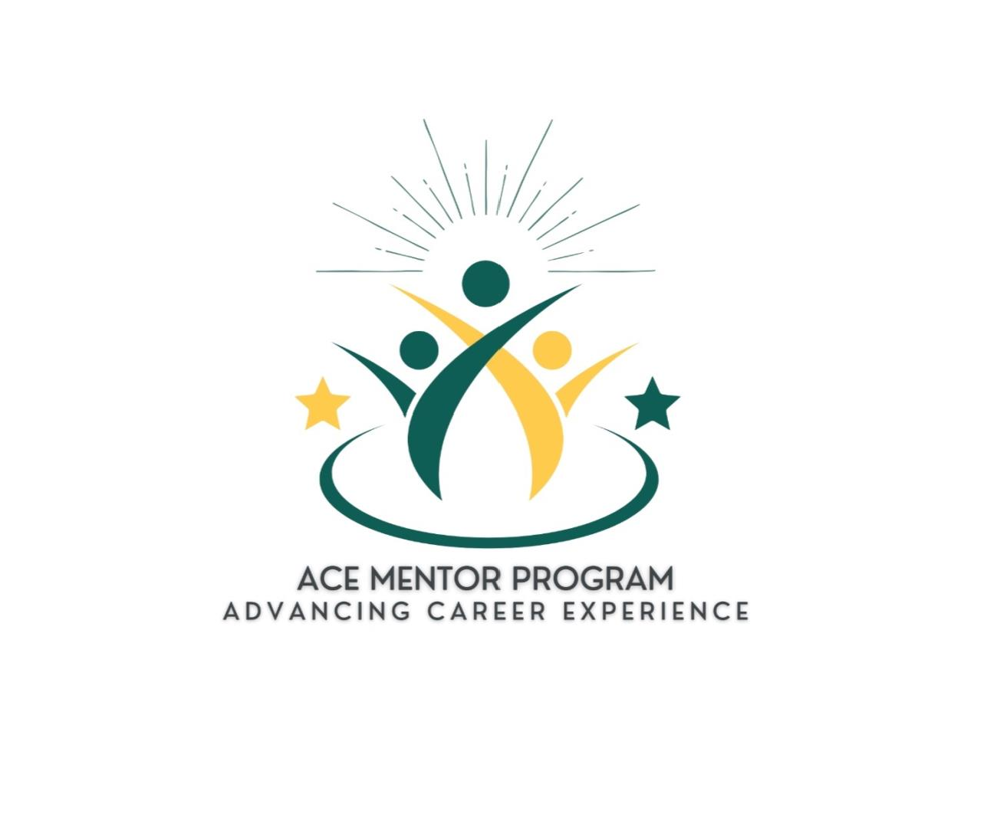ACE Mentee Handbook

**Welcome to the**

**Advancing Career Experience Mentor Program!**

We’re excited to welcome you to the Wayne State University (WSU), Mike Ilitch School of Business (Ilitch School) Advancing Career Experience (ACE) Mentor Program. We look forward to collaborating with you throughout your journey as a mentee!

The ACE Mentor Program assists undergraduate business students in exploring potential career paths, while building confidence and preparing them for life after graduation. This program

partners Mike Ilitch School of Business undergraduate students at Wayne State University with business professionals to guide them through career planning, resume development, job

shadowing, networking, and the establishment of long-term professional relationships, among other valuable opportunities. Mentorship is more than offering advice—it’s about unlocking

potential, inspiring confidence, and guiding a young professional as they discover their true capabilities.

By participating in this program. Students will be matched with professionals who provide

personalized guidance. Mentors and students are paired based on academic and career fields, common interests, and availability.

Running from September to April (fall/spring), this program is designed to be flexible and will follow an online one-on-one mentoring model, allowing flexibility and

convenience for both mentors and mentees.

This handbook provides tips, tricks, and suggestions that will prove useful in establishing and maintaining a strong relationship with your mentor. We encourage you to refer back to it to

prepare for meetings with your mentor.

Remember, the Advancing Career Experience Mentor Program is here to help you have the best possible mentorship experience. We look forward to working with you throughout your mentee experience!

~ The ACE Program Administrator

***Uplifting. Empowering. Transforming.***

# Program Requirements and Expectations

As a mentee in the ACE Mentor Program, you will be expected to do the following:

* Complete all required milestones.
* Meet with your mentor at least once a month throughout the academic year from September – April (fall/spring semester).
* Maintain regular contact with your mentor
* If you run into any problems or have any questions, you are expected to reach out to the program staff as soon as possible.

Your mentor will offer essential guidance, information, and key business skill development, which will give you an advantage in your plans after graduation.

# Time Commitment

* As a WSU Ilitch School Student, you lead a busy life, as do our mentors. Scheduling time and being accessible is extremely important.
* Once you schedule a time with your mentor each month, maintaining that time slot should be your top priority. This means you will do everything you can to avoid canceling or rescheduling your set meeting.
* If you need to reschedule, give your mentor as much advance notice as possible (at least 48 hours).
* Be respectful of your mentors’ time.

# Expectations

The ACE Mentor Program is committed to complying with the ethical standards of the National Association of Colleges and Employers (NACE) and expects students and mentors to be honest and professional. All mentees are required to abide by the WSU Student Code of Conduct and are expected to act in a professional and ethical manner at all times.

The following professional behavior is expected of mentees:

* + Adhere to the WSU Student Code of Conduct, especially in regard to the Prohibited Behaviors section.
  + Represent the WSU Ilitch School mentorship program and the WSU Ilitch School community with integrity.
  + Protect the image of WSU and the industry partner you are connected to at all times
  + Maintain confidentiality of your mentor’s workplace, work-related projects and information.
  + Refrain from posting information about your mentor or their workplace on

any social networking sites unless permission is given to you by your assigned mentor only.

* + When visiting your mentors' place of employment, dress appropriately for the work

setting. Ask your mentor at least 24 hours in advance what the dress code is, so you can prepare and dress accordingly.

* + Be prompt and respectful of your mentor’s time; arrive to scheduled meetings on time and prepared, leave on time, and give your best effort.
  + Follow through on commitments.
  + Do not conduct personal business during appointments with your mentor (i.e.

responding to personal e-mails or texts, answering cell phones, using social media, etc.).

* + Keep a positive attitude and open mind; avoid jumping to conclusions; try to make informed judgments.
  + Communicate honestly but respectfully.
  + Keep your mentor informed in a valuable and succinct way, listen and ask questions.
  + Be fair, considerate, honest, kind, respectful, trustworthy, and cooperative.
  + Assert ideas in an appropriate and tactful manner.
  + Seek feedback, accept constructive criticism, and continuously strive to improve,
  + Seek to enhance professional effectiveness by improving skills and acquiring new knowledge.
  + Talk to the ACE Program Administrator and/or the ACE Administrative Team about any uncomfortable or potentially unethical situations; problems with your mentor must be reported to the ACE Admin team.
  + If you feel victimized by an ACE-related incident, contact the Program Administrator immediately.

If a mentee does not uphold these professional behaviors throughout the ACE experience, then the mentee may be removed from the program.

# Who are the Mentors?

Mentors in the ACE Mentor Program are experienced business professionals who share

common interests with their mentees. Mentors will coach, advise, and serve as a resource. Your mentor can help you explore career paths and develop strategies for academic, professional, and social success. In essence, mentors are respected and successful professionals who volunteer

their time and knowledge to serve as coaches and advisors who provide access and opportunity. Mentors will:

* + Meet with you monthly, via phone or video conference, or potentially at their workplace or other professional setting.
  + Maintain additional contact via phone, text, email, teleconference, etc.
  + Provide support and encouragement.
  + Offer advice and constructive criticism.
  + Provide access to key organizational or professional circles.
  + Demonstrate qualities successful business leaders possess.
  + Help you clarify goals and how to achieve those goals.

# Meeting Your Mentor

You will be responsible for reaching out to your mentor and setting up the initial meeting. Please contact your mentor within the first 10 days of being matched. In this first meeting, it’s important to:

1. Exchange contact information and find out how you can reach your mentor and their preferred methods of communication.
2. Schedule your next phone call or meeting and a designated meeting location or platform.
3. Establish a time and phone number where you can usually answer calls or make contact.

If you have a concern about your mentor, please contact the WSU Ilitch School Advancing Career Experience Mentor Program Office at [ACEMentorship@wayne.edu](mailto:ACEMentorship@wayne.edu)

*\*\*\*Important Note: Requests for a different mentor based on academic background or career goals will not be accommodated. It is important to keep an open mind throughout*

*this process. Mentorship is valuable beyond academic similarities—mentors bring years of professional experience and can offer insights that are applicable across various fields and careers. Even if your mentor's background differs from your own, their guidance can help you navigate challenges, build essential skills, and provide a broader perspective that will benefit your growth and success in the long term.*

# Navigating Mentorship

Meeting regularly with your mentor is critical to establishing a strong relationship. You should plan to connect face-to-face (either virtually or in-person) with your mentor at least once per month. While you are required to meet with your mentor once per month, you are also

expected to maintain consistent contact between meetings. Mentors can provide one-on-one career mentoring and advice in-person, over the phone, via text, email or video conference.

***This program is very much “what you put into it, is what you get out of it.”***

It is your responsibility to take the lead on building and maintaining the relationship, not your

mentor’s!

You are responsible for:

* Scheduling all meetings, confirming each meeting, setting the agenda, and following up after each meeting.
* Emailing, scheduling a phone call, or arranging to meet at your mentor’s workplace or other professional setting.
* Continuing to proactively check-in regularly for the duration of the semester.

# Best Practices for Mentees

Make a Positive Impression – Stand Out in the Right Way!

* Be on time! If you are running late, communicate with your mentor by calling or texting them! You should ask for your mentor’s contact information at your first meeting.
* Discuss expectations for business attire if you plan to visit your mentors’ workplace.
* Be professional when addressing your mentor and other business professionals.
* Be eager to learn and show initiative.
* Demonstrate follow-through and willingness to apply what your mentor offers. Take responsibility for your own growth and success! Be Proactive.
* Ask questions and “pick your mentor’s brain” to gain knowledge about your profession of interest.
* Ask for and be receptive to feedback, coaching and guidance.
* Participate as an active listener when receiving feedback or constructive criticism.
* Take advantage of your mentor’s suggestions.
* Follow up with your mentor about results, lessons learned, accomplishments, etc.
* Engage with the program staff if you need help setting an agenda or navigating your relationship with your mentor.

# If Problems Arise

Sometimes, circumstances arise that prevent a mentor or mentee from having the time to commit. In this case, please let the program staff know as soon as possible. The best way to

prevent losing contact with your mentor is to start with a strong rapport and check in regularly.

However, if your mentor is not responding to your communication, ask them if they are still interested in participating in the program. If this arises or you do not hear back from your mentor within 2 weeks during the program, please contact the program staff at ACEMentorship@wayne.edu

# Steps to having a successful relationship with your mentor

How can you get the most out of your relationship with your mentor? What exactly do you want to get from that specific person? Here are some tips and tricks to get the most out of the mentor- mentee relationship.

# Establish the nature of the relationship

*This needs to be done in conjunction with your mentor. Set specific goals for the relationship – what will you get out of it? How often do you want to meet? What do you hope to accomplish*

*while working with your mentor? Be sure to behave professionally and have a positive attitude! Feeling stuck? The program staff are happy to help you get started!*

* Be considerate.
* Be on time to meetings. If you need to reschedule, give your mentor plenty of

advance notice (at least 48 hours). Recognize that your mentor is busy and respect their time.

* Be prepared.
* Respect your mentor’s limited time and come to meetings prepared and organized.
* Agree on what work should be completed for review. Write down your list of questions.
* Keep in touch!
* Be sure to communicate with your mentor. Give your mentor progress reports by email, try to see them at events, or meet for coffee chats or lunch.
* Express appreciation – say “Thank you”.

# Consider your professional goals and where you want to go in your career

*No matter how many high-flying mentors you surround yourself with, you won’t go far if you lack your own direction.*

* Ask your mentor about the profession or career field.
* Ask questions, observe behaviors and be willing to be introduced and exposed to your mentor’s professional circle, if offered.
* Take this opportunity to learn how to build a professional network.
* Meet at your mentor’s workplace (if possible) to see the office culture and set-up first hand.
* Shadow your mentor in a meeting or at their desk (virtually or in-person).
* Connect the dots between school and work.
* Discuss a current class project or ask about lessons learned while in college or a day in the life in their job.

# Elicit professional advice

*Your mentor can provide advice that could help you as you prepare for career fairs, search for internships or co-ops, and interview for full time jobs.*

* Discuss your job search
* Have your mentor review your resume and ask you practice interview questions in- person, over the phone, or through video conference
* Get tips on developing your “elevator pitch,” practice handshakes, go suit shopping, etc.
* Ask for specific advice and be receptive to input
* Consider the perspective others offer you, even if it is not what you want to hear

# Evaluate the relationship

*Receiving feedback can be uncomfortable. Listen to and consider feedback from your mentor. Be willing to have conversations with your mentor and/or the program staff about applying their advice.*

* Do you prefer gentle encouragement or brutal candor? Most mentors specialize in the former but not the latter. Let your mentor know whether their duty is to be nice or to be honest.
* Evaluate feedback and advice
* How do you know if things are going well? What are your expectations?
* Do you need him or her to “make that one big phone call” that’s going to change your life or to help you get a job by giving advice? Would you feel let down or betrayed if he or she never got around to doing so? Be clear about those expectations - maybe not at the outset, but soon enough.
* Keep focused on helping the mentor understand what they can do to best help you
* Check yourself: are your own expectations reasonable about what they can do for you?
* Let your mentor know when they helped you, and express appreciation for this guidance. Be aware of what you have to give back to the relationship. Write a thank-you card or email.

# Communicate with the Program Staff

*Navigating your relationship with your mentor can be challenging. Remember, the program’s staff are here to help!*

* Share your concerns with the Program Administrator and/or Administrative Team
* Is it difficult to contact your mentor? Do they cancel meetings at the last minute?
* Are you feeling supported? Are you learning?

# What to do and What to Ask

Sometimes it takes creativity to know how you can best work with your mentor. Here are some ideas to get the mentoring relationship going:

* Tour your mentor's facilities, if possible.
* Discuss your career goals and ways to achieve them - how did your mentor get started?
* Have your mentor look over your résumé and give you suggestions for improvement.
* Do a mock interview with your mentor.
* Find out about your mentor's educational and work experience background.
* Discuss what your mentor would do differently if they were graduating today.
* Use your mentor's company in a class project.
* Discuss your mentor's first job after graduation. What was easy/difficult about the transition from school to work?
* Ask if you can sit in on a business meeting.
* Discuss what types of responsibilities you should expect to have in an entry level position.
* Ask your mentor what was their first impression of you. Discuss ways to improve your first impression.
* Discuss what prospective employers look for during recruiting events.
* Discuss the advantages and disadvantages of graduate school directly after graduation.
* Find out what professional organizations and trade publications are available for your field.
* Find out what your mentor sees as the future direction of their profession.
* Ask your mentor to recommend some books to read relating to your field.
* Share your career goals and how you’d like to achieve them; describe what type of position, salary, and responsibilities you expect in an entry-level position.
* Discuss how to balance career, family, and community service.
* Discuss relevant coursework and projects with your mentor.
* Discuss networking with your mentor.

# Ending the Mentor Relationship

All good things must come to an end, and there will be a point when you must end your mentoring relationship, at least formally, through our program. When you first began this

program as a mentee, you probably wanted to make progress in a certain aspect of your career or life. You committed the time and energy to meeting with and learning from your mentor, so there may be some lingering emotions and reflective thoughts as you approach your final meeting. It can be difficult to express gratitude for a mentor’s voluntary commitment and you may feel awkward telling your mentor that the mentoring conversations are no longer needed.

The good news is that most mentors are seasoned managers who understand the ebbs and flows of professional life. When ending your formal mentor-mentee relationship through the program:

* 1. **Meet face-to-face.** A best practice for communicating with your mentor about ending the formal mentoring is to tell the mentor face-to-face (either virtually or in-person).
     + Plan to spend five to ten minutes at the end of your next session talking about it
     + Suggest a focus for the final session. You might like to celebrate all that has been accomplished and have a more informal session. You could also ask for help in identifying next steps for your career.
  2. **Be clear and concise.** Begin with a simple, clear statement about how you see your career and the mentor relationship at this time. Explain how your situation may have changed since you first met. For example:

*“Thanks to you, I have a much better understanding of …”*

*“I’ve come a long way during the past several months. At this point, I realize that I need some time to focus on the areas that we’ve talked about. I am grateful for your guidance and support. I feel that we’ve accomplished what I needed at this time.”*

* 1. **Reflect and appreciate.** Express gratitude to the mentor for his/her time and

contribution to your progress. Let your mentor know how talking with him/her has benefited you. For example:

*“You’ve helped me interpret and apply the feedback that I got from my boss. I really appreciate your insights and support.”*

* 1. **Be flexible.** Remember that ending the formal mentor relationship may not mean ending the relationship. Many mentors and mentees continue to stay in touch

informally and support each other in a variety of ways over time. Ask for the

relationship to continue informally if you would like to maintain the relationship. For example:

*“Would you be willing to hear from me occasionally in the future?”*

* 1. **Say thank you.** Write a personal thank you note and mail it to your mentor within two

(2) days after your last session or email him/her within 24 hours of your last session.

Perhaps the most important advice for ending a mentoring relationship is to handle the situation in a forthright way rather than avoiding it. If you manage yourself with respect for the other

person, communication will go well.

# Closing Note

As you navigate your relationship with your mentor throughout the program, we encourage you to use this handbook as a resource. The tips, tricks, and information throughout will prove useful as you are at different stages of the mentor-mentee relationship. If at any point you have questions or concerns, please contact the Advancing Career Experience Mentor Program staff. We are here to help you:

* If problems arise.
* If you have questions as you navigate your mentor-mentee relationship.
* If you haven’t heard from your mentor in a while.

You may contact the WSU Mike Ilitch School Advancing Career Experience Mentor Program at

[ACEMentorship@wayne.edu](mailto:ACEMentorship@wayne.edu). We look forward to working with you!

Happy Connecting!  
The ACE Program Administrator

1/2025