ACE Mentor Handbook

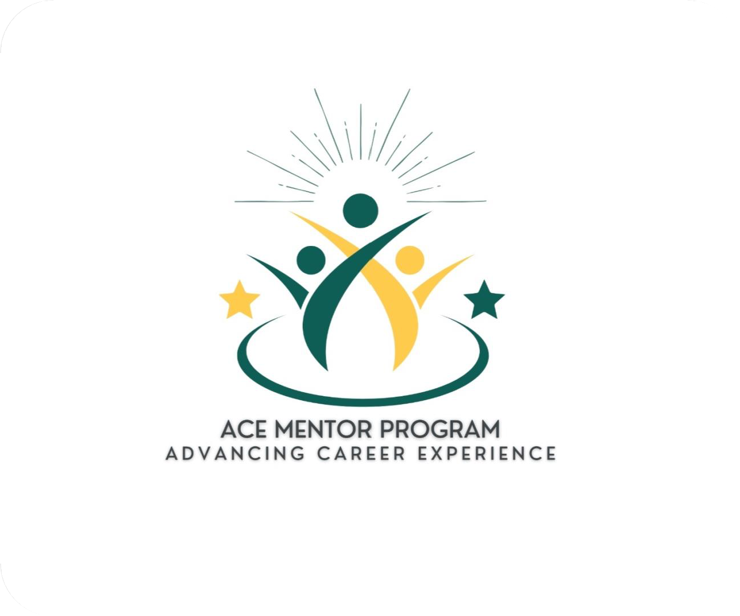

**Welcome to the**

**Advancing Career Experience Mentor Program!**

We’re excited to welcome you to the Wayne State University (WSU), Mike Ilitch School of

Business (Ilitch School) Advancing Career Experience (ACE) Mentor Program. We look forward to collaborating with you throughout your journey as a mentor!

The ACE Mentor Program assists undergraduate students in exploring potential career paths, while building confidence and preparing them for life after graduation. This program partners Mike Ilitch School of Business undergraduate students at Wayne State University with business professionals to guide them through career planning, resume development, job shadowing (if available), networking, and establishing professional relationships, among other valuable opportunities.

Mentorship is more than offering advice—it’s about unlocking potential, inspiring confidence, and guiding a young professional as they discover their true capabilities. Running from September to April (fall/spring), this program is designed to be flexible and will follow an online one-on-one mentoring model through the Xinspire platform, allowing flexibility and convenience for both mentors and mentees. The ACE Mentor Program is open to undergraduate business students at all levels—freshman through senior—and will focus on developing real- world skills, personalized guidance, and building long-term professional relationships.

This handbook is designed to provide you with a variety of helpful tips, strategies, and suggestions that will be instrumental in building and maintaining a strong, supportive relationship with your mentee. It offers practical advice for fostering open communication, setting goals, and navigating challenges, ensuring that both you and your mentee can have a successful and fulfilling experience. We encourage you to refer back to the handbook as you prepare for your meetings with your mentee, as it can serve as a helpful resource throughout the mentorship journey.

Remember, the ACE Mentor Program is here to support you in creating the best possible experience for both you and your mentee.

We are excited to work with you and look forward to being part of your journey as a mentor!

~ The ACE Program Administrator

***Uplifting. Empowering. Transforming.***

## What is Mentoring?

*“A mentor is an individual with expertise who can help develop the career of a mentee.”* **-** The American Psychological Associate

* Mentoring is the process of an experienced individual helping another person develop his or her goals and skills through a series of time-limited, confidential one-on-one conversations and other learning activities.
* As a mentor, you will have the opportunity to share your experiences and wisdom, develop a new relationship, and deepen your skills.

## The Role of the Mentor

As a mentor, there are numerous ways to help your mentee grow. Below are several examples...

* Professional development:
  + Provide guidance on career choices, offer advice on navigating organizational structures, and help mentees set and achieve goals.
  + Help mentees develop specific skills needed for their jobs or future careers, such as leadership, communication, and problem-solving.
  + Mentors can introduce mentees to professional networks to help mentees connect with individuals and new opportunities.
* Personal growth:
  + Assist mentees in understanding their strengths, weaknesses, and values essential to personal growth and self-improvement.
  + Use encouragement and constructive feedback to help mentees build confidence in their abilities and decisions.
* Educational support:
  + Offer advice on academic decisions, study techniques, and career paths related to their field of study.
  + Assist students with projects and schoolwork, offering expertise, feedback, and resources to enhance academic work.
* Leadership development:
  + Exemplify effective leadership behaviors and principles, providing a model for mentees.
  + Help develop strategic thinking skills essential for leadership roles.
* Career advancement:
  + Help mentees explore different career pathways, offering advice on job searches, interviews, and career planning.
  + Assist mentees in setting realistic goals and developing actionable plans to achieve them.

# Who are the Mentees?

Mentees in the ACE Mentor Program are current Wayne State University, Mike Ilitch School of Business undergraduate students that come from diverse backgrounds. Each mentee is willing to connect at least once per month and is advised to maintain consistent contact between meetings. Mentees have been told that they are responsible for:

* Scheduling all meetings, confirming each meeting, setting the agenda, and following up after each meeting.
* Emailing, scheduling a phone call, or arranging to meet at your mentor’s workplace (if available) or other professional setting in the correct attire.
* Continuing to proactively check-in regularly for the academic semester.

# Program Details

As a mentor in the ACE Mentor Program:

* Our administration has set a few milestones at the beginning of your partnership that you and your mentee must work towards completing (profile picture, setting initial meet with mentee, virtual orientation, etc.).
* Have the time to communicate with the mentee at least once a month for the full academic semester unless you and your mentee have agreed on a different meeting arrangement.
* Assist mentees with objectives and goals for desired career paths and key business skill development to help them plan after college.
* Meet monthly, via phone or video conference, or potentially at your workplace or other professional setting.
* Maintain additional contact via phone, text, email, teleconference, etc.
* Provide support and encouragement.
* Offer advice and constructive criticism.
* Provide access to key organizational or professional circles (if able, willing, and applicable).
* Demonstrate qualities successful business leaders possess.
* Help clarify goals and how to achieve those goals.

# Time Commitment

As a volunteer mentor, the mentees and staff completely understand that you lead a busy life! We only ask if you’re unable to have a scheduled meeting with your mentee, that this is communicated as soon as possible.

We have detailed to mentees that mentors are volunteers and should respect your time as much as possible. Our administration has expressed that they must give advanced notice of any changed plans of at least 48 hours and advised them to do everything in their power to not have any rescheduling or cancellations on their end.

Must be available from September to April (fall/spring) unless stated otherwise.

# Navigating Mentorship

Meeting regularly with your mentee is critical to establishing a strong relationship. You should plan to connect face-to-face (either virtually or in-person) with your mentee at least once per month.

***This program is very much “what you put into it is, what you get out of it.”***

This quote is also shared with all mentees.

## If Problems Arise:

Sometimes a mentor or mentee might have circumstances arise that prevent them from having the time to commit. In this case, please let the program staff know as soon as possible.

If you have any concerns about working with your mentee or any other questions during the program, please contact the program staff.

# Meeting With Your Mentee

## Establish the Nature of the Relationship

*Set specific goals for the relationship – what will you and your mentee get out of it? How often do you have time/want to meet? What do you hope to accomplish while working with your mentor? Be sure to behave professionally and have a positive attitude! Feeling stuck? The program staff are happy to help you get started!*

* Get to know each other in the initial meeting! Spend time understanding each other’s backgrounds, interests, and professional goals to help build support and trust.
* Share what you both expect from the relationship- frequency of meetings, communication styles, and specific areas of focus.

## Consider mentee’s professional goals and where they’d like to go in their career

* Help mentee establish short- and long-term goals. (SMART- Smart, Measurable, Achievable, Relevant, and Time-Bound).

## Define Roles and Responsibilities

* Clarify what you can provide to the mentee- networking opportunities, feedback, guidance, etc..

## Communication Plan

* We highly recommend setting preferred contact method and the following meeting dates and times in advance.
* If needed, remind the mentee that their responsibility is to be proactive and apply the advice given.

## Feedback Mechanism

* Agree on how the mentee would like feedback to be given.
* Encourage open communication.

## Review and Reflect

* Periodically review the progress of the mentoring relationship and reflect.

# What to Do, Ask, and Offer

Sometimes it takes creativity to know how you can best work with your mentee. Here are some ideas to get the mentoring relationship going:

* If able to, have mentee tour facility or have them shadow for the day.
* Share your experiences as you see fit for the mentee- how did you achieve your career goals?
* Look over mentees’ resume and help them make edits and finalize.
* Do a mock interview with mentee to help prepare them.
* Discuss things that you might’ve done differently during your educational career.
* Talk about your experience with the transition from school to work?
* Have mentee sit on a meeting.
* Discuss what types of responsibilities they should expect to have in an entry level position.
* Discuss ways mentee can improve their first impression.
* Help your mentee review job applications, their LinkedIn profile, etc.
* Discuss what prospective employers look for when hiring and/or during recruiting events.
* Discuss advantages and disadvantages of graduate school directly after college.
* Find out what professional organizations and trade publications are available for mentees’ interested field.
* Discuss what you see as the future direction of your profession.
* Recommend some books to read relating to mentee’s interested field.
* Ask the mentee to share their career goals and how they’d like to achieve them; what type of position, salary and responsibilities they expect in an entry level position. Share insight into what you think.
* Discuss how to balance career, family, and community service.
* Ask the mentee about their coursework and projects and if they need any help.
* Discuss networking tips and offer to take them to networking events.

# Ending the Mentee Relationship

*Ending the mentor-mentee relationship can be a sensitive process. Here are some tips for mentors to ensure the relationship concludes on a positive and constructive note:*

* At the beginning of the relationship, discuss the potential duration and goals of the mentorship.
* Reassess goals and review progress throughout the entire mentorship.
* Acknowledge the effort and progress made by the mentee and express gratitude for their commitment.
* Summarize achievements and growth throughout the mentorship.
* Offer constructive feedback on areas where the mentee can continue to develop.
* Help mentee outline their next steps and future goals.
* Offer to be available for occasional guidance or support if appropriate.
* Introduce mentees to other professionals or mentors who can help them continue their growth.
* Keep the door open for future networking opportunities and maintain a professional relationship if both parties agree to stay in touch.
* Ask the mentor to provide you with feedback on how to become a better mentor.

# Closing Note

As you navigate your relationship with your mentee throughout the program, we encourage you to use this handbook as a resource. The tips, tricks and information throughout will prove useful for you at different stages of the mentor-mentee relationship.

If you have questions or concerns, please contact the Advancing Career Experience Mentor Program staff. We are here to help you:

* If problems arise.
* If you have questions as you navigate your mentor-mentee relationship.
* If you haven’t heard from your mentee in a while.

You may contact the WSU Ilitch Advancing Career Experience Mentor Program Office at [ACEMentorship@wayne.edu](mailto:ACEMentorship@wayne.edu)

We look forward to working with you!

Happy Connecting!   
The ACE Program Administrator